**ELASTIC CONTAINER SERVICE (ECS)**

* ECS is used to launch Docker Containers on AWS
* In order to use ECS, you must provision and maintain the infrastructure(the EC2 instances)
* AWS will take care of starting/stopping the containers
* ECS has an integration with Application Load Balancer
* Now the ECS service, at any time has a new docker container, it will be smart enough to find on which EC2 instance to place that docker container.

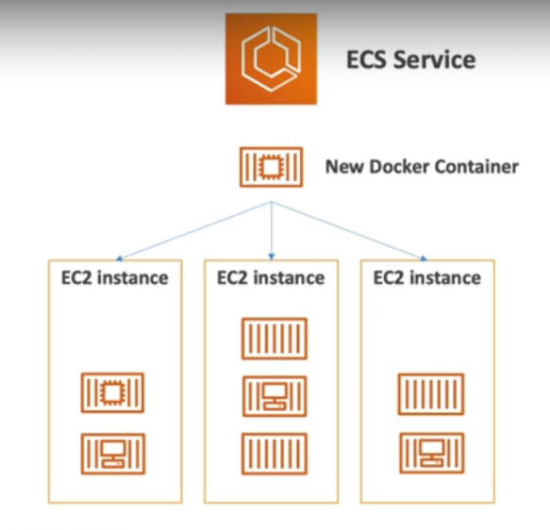

**FARGATE**

* Fargate is also used to launch docker containers on AWS.
* With fargate, we don’t need to provision any infrastructure (no EC2 instances to manage),hence simpler!
* It is a serverless offering as we don’t manage any servers
* AWS will just run the containers for you based on the CPU/RAM you need

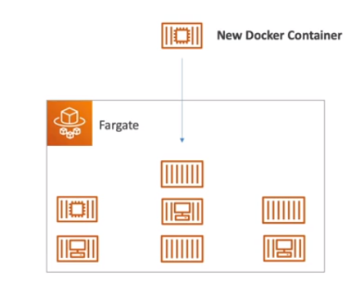

* With fargate, a new docker container will be running, but we won’t know where exactly it will be running.

**NOTE:** With ECS, we would be knowing on which EC2 instance, our docker container will be running, but with fargate, we won’t know on which EC2 will be running, hence serverless.

**ELASTIC CONTAINER REGISTRY (ECR)**

* ECR is the service used to store the docker images, so that it can be run on the AWS.
* It is a private docker registry on AWS, and this is where we are going to store our docker images, so that it can be run using ECS or the fargate.

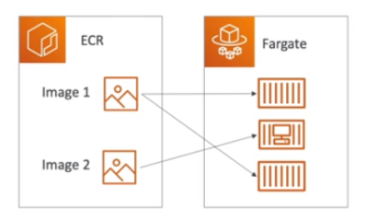

**SERVERLESS**

* Serverless is a new paradigm here developer’s don’t have to maintain or manage servers anymore…
* They just deploy codes or functions
* Initially Serverless = Function as a Service (FaaS)
* Serverless was pioneered by AWS Lambda but now also includes anything that’s managed: ‘databases’, ‘messaging’, ‘storage’ etc.
* Serverless doesn’t mean there are no servers, it means you just don’t manage/provision/see them.

